Tarsiers Security Company Business Plan
First name I. Last name
Your Title

A. Executive Summary 4
A1. Company Identification 4
A2. Mission of the Company 4
A3. Business Goals 4
A4. Keys to Success 4
B. Company Summary 5
B1. Industry History 5
B2. Legal Form of Ownership 5
B3. Location and Facilities 5
B4. Management Structure 5
B5. Products and Services 5
C. Market Analysis 6
C1. Target Market 6
C2. Industry Analysis 6
C3. SWOT Analysis 7
D. Market Strategy 8
D1. 4Ps 8
D2. Price List 8
D3. Promotional Strategy 8
D4. Sales Forecast 8
E. Implementation Strategy 9
E1. Overall Strategy 9
E2. Monitoring Plan 9
F. Financial Statements and Projections 10
F1. Forecasted Profit and Loss Statement 10
F2. Forecasted Balance Sheet 10
G. Financial Report 11
G1. Financial Projections 11
G2. Financial Position 11
G3. Estimated Capital/Investment Needs 11
H. References 12

Executive Summary
A1. Company Identification:
The Company's name is Tarsiers Security Company. The name is derived from a small primate animal named tarsier, commonly found in Southeast Asia. Tarsier is a unique animal because it has wider eyes that take the better part of its head (Shekelle et al., 2017). Most importantly, the nocturnal animal has the sharpest eyesight, especially during the night. The Company plans to manufacture a tiny but powerful security camera, two centimeters in radius, and able to see clearly in darkness. The camera will go by the name Tarsier Security Company or T.S.C. as its abbreviation.
In the Ashbury Complex, Tarsiers Security Company will be located along Oak Street in Thompson city (Manitoba-Canada).
A2. The mission of the Company:
The Company recognizes the significance of a mission statement as a navigation tool in its operations. The Company's mission is to serve the Canadian and the global community by guaranteed property monitoring free from power interruptions.
A3. Business Goals:
To realize our mission, we plan to expand our services by going international to take advantage of globalization. We target to open subsidiaries in Egypt (In North Africa), Hongkong (in Asia), and Miami (in the United States of America). The move will enable the Company to swell its revenue potential by gaining access to a vast base of international customers. The Company plans to go global to diversify our market. This will help when the Canadian market is hit with financial turmoil or if the market hits maturity and earnings shrink (Topno, 2019). Also, it will help the Company to lower its operational costs by taking advantage of cheap labor and low operational demands in the target countries. Besides, the Company stands to improve its image internationally by operating in diverse environments.
The second goal will be to provide excellent customer service to build a profitable empire by attracting and retaining new customers to emerge as the leading players in the industry. Every customer who knocks at our door is crucial to building our business and propelling us into a brighter future. We believe that a single customer can ruin or form company pillars for prosperity. We shall indeed produce high-quality security cameras with unique features to solve the traditional problems of detectable cameras and malfunctions during power blackouts. Apart from such an advantage, we yarn to rely on customer referrals to enable us to prosper. For better service delivery, we shall recruit the most competent employees in respective fields to guarantee efficiency in service delivery in all dockets.
A4. Keys to Success:
One of our primary keys to success will be differentiating our products and services from industry players. Our product will be our selling point and our company ambassador due to its uniqueness. In brief, Tarsier Security Camera will be a digital camera that will be unnoticeable but accompanied by the false type. It will also have a powerful camera that can run for eight hours without relying on a power supply.
Another key to our success will be producing high-quality cameras that will be sold at relatively affordable prices. Such a strategy is expected to sway customers our way due to affordability and also guaranteed quality. We expect the relatively lower prices to increase sales and also enable the Company to register more profits.
Lastly, our anchorage will be vested in the quality of our employees. Quality products and quality services can only be met via the hiring of competent employees. From such a standpoint, we plan to hire talented employees in all segments. One advantage that we have is that the Company's Chief Executive Officer is an electrical engineer with a degree in business management. The Company expects to handsomely remunerate our employees and also reward creative minds for stimulating creativity. Our management style will be democratic and open to enhance employee development via training and departmental collaborations.
- Company Summary
B1. Industry History:
Commonly referred to as CCTV (Closed Circuit Television), security cameras commonplace in Canada date back to 1990 when the government initiated open-street camera surveillance in Sherbrooke (Quebec). It is aimed at taming crime and monitoring traffic (Piza, 2021). Initially, the cameras were used in entertainment joints and affluent residences for security purposes. The significant rise in the use of CCTV in Canada was influenced by the culture of the U.K. to install CCTV along open streets. The success story of the U.K. to fight crime with such systems fueled the need for CCTV around the world, including Canada. When images of a CCTV in a Merseyside mall identified the killers of Jamie Bulger in 1993, the government increased funding of CCTV projects to cover all significant streets and busy public places. Most projects gained momentum in 2000 to fight violent crimes that were sky-high. Toronto's CCTV projects were influenced by the shooting of Jane Creba in 2005 on boxing day (Piza, 2021). Other municipalities started using temporal CCTV during functions.
By 2007, at least 15 cities had CCTV on their streets, while 17 municipalities were considering such projects. The projects sometimes met public resistance due to privacy issues and controversies in their court usage. The fear of crime fueled by a rise in terrorism justified the installation of security cameras in both private and public spaces. Initially, Canada consulted the U.K. both for purchasing of CCTVs and their schemes. The higher demand attracted CCTV camera companies to Canada in the late 200s. They include the Avigilon Company that Fernandez Boris founded in 2004 in Vancouver (Piza, 2021). More manufacturing companies emerged. They include Vicon, Dahua technologies, Milestone, N.V.T. Phybridege, Videotec, 3x Logic, and 3D Eye.
B2. Legal Form of Ownership:
Legal ownership is an integral part of a business organization. The type of ownership determines the future of a company. Tarsier Security Camera company will be registered as a limited partnership company. Canadian business law (Act, R. S.O. 1990, c. L. 16) defines a limited partnership as a "business entity that has both general and limited partners who join hands to venture into a specific business" (Chechurina & Grin, 2020, p. 67). Limited partners who take up active roles become liable to the business too. Steve Fortunes, the founder of the Company, will partner with his longer-term business associate named Alpha Carlos. In this case, Carlos will be Fortune's co-founder, and the two will be the top leaders of the Company, with Fortune as the Chief Executive Officer and Carlos as the Assistant Chief Executive. The two shall determine how to make decisions that matter to the Company and structure the most appropriate ways of sharing losses and profits. Another discussion of concern is about conflict resolution. Both Carlos and Fortune shall discuss the mechanisms that can be used to address conflicts that may arise in line with company operations. Another vital element to be covered is the mechanism of resolving the business or altering the general structure of the Company. All such details shall be presented to the business registrar of the province.
B3. Location and Facilities:
The Company's premises will be located in the Ashbury Complex along Oak Street in Thompson city (Manitoba-Canada). We have entered leasing negotiations with StepUp Investment company that owns the building. The building is much suitable for our company requirements for it has spacious rooms that can be subdivided into various sections. It has two vacant halls that are 275m square. It has other attached rooms that are 100m square. The enormous spacious halls can be used as camera manufacturing centers with Chief Engineer's office. The other two rooms can be used for management and marketing functions. The place has reliable sources of water and power with modern toiletries and easy-to-clean floors. Another advantage is that its main entrance faces Oak Street hence strategically placed for easy transportation and access. It is only 15 minutes from Thompson International airport. This will enable easy transportation and receiving of inputs and also human resources travels.
The camera project requires various facilities for the smooth running of its operations. One of them is furniture. We shall require office tables, chairs, and cabinets. Also, there is a need to have lab tables and raised chairs. The expansive halls don't have an air conditioner. Hence, the Company will have to buy one. Also, the place lacks enough parking space hence we shall look for an alternative space to serve the same purpose. To add, we must have an alternative source of power to address the occurrences of power blackouts. Having a standby generator will serve us well. The generator will ensure a steady power supply to evade unnecessary disruptions, especially at the manufacturing lab. Another vital consideration is the internet and company electronics. There is a need for a stable internet connection to serve both the offices and the lab operations. Also, the Company needs to buy various stationery and computers too.
B4. Management Structure:
The Company understands the value of a well-structured team in the realization of company goals and mission. We plan to strictly attract the most talented individuals to force a robust team ready to live to the expectations spelled out in our mission and goals. Based on such facts, our team that will be led by Steven Fortune (the C.E.O.), who is also the founder, will comprise of the Chief Executive Officer, Assistant Chief Executive Officer, Human Resource Manager, Chief Accountant, Sales and Marketing Manager, Sales Agents, Chief Camera Engineer and Technician, Customer Care Officer and Sales and Marketing Manager. The assistant C.E.O. will assist the C.E.O. in the running of the Company. The Human Resource Manager will come third in power ranking, and they will be responsible for dealing will issue related to the labor force. The Chief Engineer will assist the Human Resource Manager in the smooth running of the Engineering department while the sales and marketing manager will be in charge of the marketing team. The Chief Accountant will be responsible for addressing company financial matters. Their responsibilities can be broken down as follows;
Chief Executive Officer
- Enhance Company's effective management via recruiting, orienting, selecting, motivating employees, disciplining managers, determining policies after consultation, and delegating tasks.
- Responsible for determining the direction of the Company
- Responsible for determining product and service prices, signing deals, documents, cheques, and other relevant connections on behalf of the Company.
- He/she should strive to implement the vision, goals, and mission of Tarsier Security Camera company.
Assistant Chief Executive Officer
The officer will assist the C.E.O. in the smooth running of the Company as determined and directed by the C.E.O. Some of the responsibilities for the Assistant shall include helping the C.E.O. to;
- Develop and implement the general strategy of the Company
- Sign documents on behalf of the C.E.O.
- Evaluate the progress and the success of the Company
- Ensure that the set prices and the delegated duties are well-executed.
The Human Resource Manager (HR)
- Account for the evaluation, training, and assessment of the company employees
- Orients new members about the Company's mission, goals, relations, and any other relevant aspects
- Perform administrative tasks including defining job positions and managing recruitment processes
- Hold meetings to revisit the effectiveness of human resource policies.
Chief Accountant
- Responsible for developing budgets, preparing and providing financial reports and their analysis
- Perform risk analysis and financial forecasting
- Acts as an internal auditor and financial advisor. The accountant needs to ensure that the Company is tax-compliant
- Perform financial transactions on behalf of T.S.C.
Sales and Marketing Manager
- Carries out market research and win more clients and also plans sales campaigns
- Write winning proposals and also negotiate charges on behalf of T.S.C.
- Determines business opportunities, develops and trails contracts and business deals.
- Supervise and advocate for the needs of our clients
- Determines ways of escalating sales and develops mechanisms of swelling product and service sales
Chief Camera Engineer and Technician
- Responsible for the designing, manufacture, repair, and installation of Tarsier Security Camera
- Conducts training, offer consultancy services, and chooses the best software and camera specifications
- In charge of work schedules in the labs
- Supervises the manufacturing processes of the cameras
Customer Care Officer
As suggested by the title, the officer will ensure customer satisfaction and address their issues.
- The officer will carry out responsibilities given to him by the manager
- Communicates with clients via both digital and verbal communication
- Receives and distributes company information
- Provides information about product specifications, warranties, delivery options, and maintenance procedures.
- Supplies valid information to customers concerning, for instance, promotions and offers
Sales Agents
- Participate in sales campaigns
- Promote products in the field by enlightening customers on product specifications
- Help in generating leads and gaining new clients and contracts
Management Structure
C.E.O.

ASSISTANT CEO

HUMAN RESOURCE MANAGER

SALES & MARKETING MANAGER
CHIEF CAMERA ENGINEER & TECHNICIAN

SALES AGENTS
CUSTOMER CARE OFFICER

B5. Products and Services:
The Company's Tarsier Security Camera will be 2cms in diameter and can record videos through motion detection using a nanny cam sensor. The camera is connected to a powerful battery that runs for seven hours in a blackout. Its sensor will allow it to have a strong night vision that can reveal objects for easy identification. Also, it will have an infrared illumination to prevent it from glowing in the dark. The camera will have an extra feature that will enable it to sense smoke and signal to the fire department. Also, the camera will come with a decoder that can store images of chosen people, for instance, the managerial team or family members. The camera will match the images when placed in sensitive areas (for instance, strong bank rooms and V.I.P. residential areas). If any unrecorded image is detected, the camera will raise the alarm and display the video and verbal conversation of the intruder over the owner's phone or other devices like a smartwatch. Such a device will be important in sensitive areas, such as banks and high-end residential areas.
Apart from our Tarsier Camera, we shall offer camera servicing and installation services for digital security cameras in Canada and our international branches in Egypt, Hong Kong, and Miami. We shall be offering free installation services to individuals or companies that buy our cameras and are located with a radius of 20 kilometers from our facility. Apart from installation services, the Company will be offering security camera video analysis at affordable fees and free of charge from our buyers. In addition, we shall be offering paid training in security camera manufacture and maintenance and consultancy services in matters related to security camera systems. The digital era has led to more interest in learning the art and science behind security cameras. Also, there are many types of cameras suitable for various needs that require consultation to make the right choices.
- Market Analysis
C1. Target Market:
Tarsier Security Company targets to sell its products mainly to the Canadian market before going international. The home city is among cities with high rates of crime. This means that the city will form our primary market due to the high demand by both the government to install security cameras along the streets and in public places. Also, our extensive research revealed that there are more other cities that struggle with crime issues. They include Hamilton with a crime score of 53.36, Regina (53.8), Brampton (67.2), Winnipeg (65.6), North Bay (83.4), Surrey (87.2), among others. Most of the business owners cite vandalism and break-ins as their most worry. The government is also worried about the high rates of car hijacking and assault in the streets (Cesaroni, & Doob, 2020). For instance, Lethbridge records over 100 cases of car hijackings annually. Residents in Red Deer affirm that walking alone in the streets is dangerous, even during the daytime. More shopping malls and hotels are coming up, high flow of FDI in retail and construction sectors, high rates of cyber-attacks on government agencies, including private firms, are among factors that fuel demand for I.P. cameras like the Tarsier Security Camera.
The government plans to spend $ 179 million to improve cyber security via modern digital connections (Cesaroni & Doob, 2020). Also, most businesses and residential homes have analog CCTV systems; hence, there is a higher demand for upgrading to the new digital I.P. systems or installing new ones. Another notable statistic is that the government has rolled out many projects that require CCTVs. They include the Hi-Rise Residential Complex in Toronto, Burnaby Hospital Redevelopment Phase 1 in British Columbia, and expansion of transport facilities. They include expanding airport terminals like Naujaat, Chester Inlet, and Kugluktut (Kamali et al., 2021). Also, the government has multiple mega tenders for CCTV installation and maintenance, with Ontario expanding its coverage of CCTV. Other areas in need of CCTV include commercial offices, the industrial sector, banking, educational, and healthcare institutions. Also, the number of homeowners has increased due to the increase in Canada's middle- and high-income earners. The homeownership rate had improved from 66.2% in 2018 to 68.27% in 2019 (Allen et al., 2020). The Company mainly targets individuals between 25 and 40 years who make up 40% of Canada's middle class.
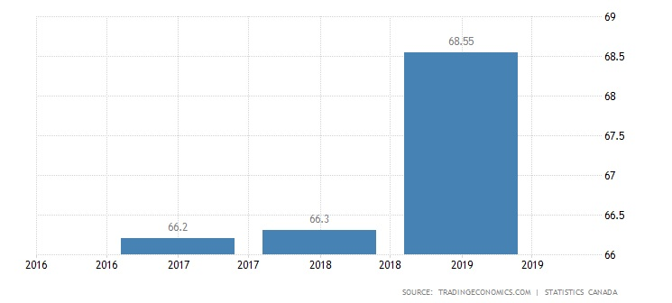
The many CCTVs in Canada., it is expected that the need for maintenance and consultancy will be high.
C2. Industry Analysis:
In Canada, security cameras, security cameras, and alarm installers fall under the Security Service Industry. Most of the companies under this docket also offer installation and maintenance services for security cameras. Canada has over 200 registered companies that manufacture such cameras. Examples include ACTI, Sony, and Axis. The industry's growth is expected to be positive because of an increase in the security camera demand by both the public and the private sector. Also, many of the old security devices and systems need an overhaul while the government has several surveillance projects to roll out. They include upgrading all the security details of the airports and highways. The industry is expected to grow by 11.4% by 2025 from USD 45.5 billion to USD 74.6 billion. These years, the security segment expects $341 million. The average earnings for each Smart Home will attract $ 247 annually (Norris & Armstrong, 2020). In Canada, persons with criminal records are not allowed to venture into the security industry. The industry has a bright future due to increased homeowners, the banking sector, and government projects.

S (Strengths)  1. Strategic location along Oak Street  2. Exceptional camera details  3. Excellent customer care culture | W (Weaknesses)  1. The Company is new in the CCTV security industry  2. Finances  3. Dependence on middle- and upper-class strata
O (Opportunities)  1. High crime rates in Thompson and other cities in Canada  2. Our location along Oak  3. High number of analog CCTV. | T (Threats)  1. Unfavorable national policies  2. Imitation of our technology  3. Competition from established firms
C3. SWOT Analysis:

Our significant opportunities include high crime rates in Thompson and other cities in Canada, especially those in the prairies. Many cities in Canada struggle with crime issues. North Battleford, Hamilton, Regina, Winnipeg, among others. Such areas will create a reliable market for our T.S.C. and installation services. Our strategic location along the busy Oak Street will make transportation of goods and human resources easier. Also, it is near Thompson International airport. The street has many businesses and government offices that will be our potential immediate customers. To add, the high number of analog CCTVs means that the owners will need an upgrade or change their security systems to I.P.
Our unique cameras capable of detecting smoke and identifying undocumented individuals are expected to differentiate us from our competitors. Also, our quality customer service will enable us to attract and retain customers and create a positive business image.
Our significant weaknesses are that we are new in the CCTV hence we might face both managerial and logistics problems. Also, we may lack trust from the public, which might limit our ability to win substantial contracts. Financial problems might sabotage our ambition to hire talented individuals and fail to purchase all the needed facilities and equipment. To add, depending on the middle and upper classes will limit our customer base, eliminating the lower class from our equation.
Some of the threats include unfavorable policies, for example, high taxation and stringent registration, and high taxation that may limit our operations. Also, other companies might imitate our camera model hence neutralize our advantage. Lastly, we might fail to penetrate the market due to high competition from already established firms with a vast customer base and public trust.

D. Market Strategy
D1. 4Ps:
Marketing mix forms the foundation of a business. It entails a set of marketing tools that a company employs to chase its marketing goals (Chen, 2018). T.S.C.'s 4 Ps are as below.
Product— A company's marketing mix determines the earnings and the general output of any given company. Our product mix encompasses services and goods related to Information Technology and security. For a start, our main product is Tasier Security Camera which will serve as a brand ambassador before we gain roots to diversify our products and services. Our camera shall have a warranty of two years. In a shorter description, the Tarsier Security Camera is a High-Definition camera that uses Internet Protocol (I.P.) to enable remote control mechanisms. The camera uses 460 lines in its coverage enabling it to see clearly in darkness. The tiny wireless camera comes in varieties of colors. It uses a network video recorder and has a glass cover making it weather-resistant hence it can be used both indoors and outdoors. Our services include installing the whole CCTV system and upgrading the analog systems of I.P. without dismantling the system. Also, we shall be offering repair services for malfunctioning systems. Our chief engineer will also be offering consultancy services about installation, camera choice, and service quotations.
Price— The Company plans to use the competitive pricing strategy by charging relatively lower prices than our competitors. The strategy aims at enabling the Company to penetrate the market (Zhang, 2020). Overcharging or undercharging will be avoided in the provision of installation and servicing of the security devices. We shall then switch to value-based pricing after our customers and the general market acknowledges the value of our products and services. This will enable us to increase sales and also win customer loyalty. Our customers will be able to use any of the payment methods they find convenient. They include bank transfers, mobile money, cash, online banking, and even cheques. The Company plans to give discounts to those who buy our T.S.C. (See the price list on the next page). The discounts on our services (installation and maintenance of CCTV systems) will be offered based on the radius from our retail stores.

Place— Tarsier Security Company will use various destinations to distribute and deliver our products across Canada to our target customers. For easy access by our customers, we have carried out extensive geographical research, determined various suitable locations in significant towns, and made down payments. Our retail stores will be located in Commercial tower (first floor-room 23), Freedom House (ground floor-room 13) in Winnipeg city, Vancouver Plaza (third floor-room 7) in North Bay, and Fista Business Center (ground floor-room 3) in Hamilton. We shall also have a significant store in our Oak Street where we will carry out our direct selling. Also, we have partnered with various authorized sellers to sell our products. They include all outlets of Hamilton Technologies and Amazon. We shall also sell our products and services via our website and Facebook page.
Promotion— We plan to carry out direct selling out our main outlets. Our employees shall also hunt for potential clients for our products and services by word of mouth. Also, our first customers will be given various gifts, for example, our printed T-shirts, pens, and snacks, and be encouraged to spread the gospel about our products and services.
More customers will be reached and won via the use of introductory letters and brochures. The letters will be availed to organizations, households, innovation magazines and also distributed in innovation seminars. Our sales teams will also be attending expos to market our services and products, especially the T.S.C. Security Camera and its functionality. A short video showcasing the T.S.C. camera will be shown on our website to boost publicity. Also, our technicians will be posting the services they offer to our website and Facebook page twice per week. The Company will utilize digital platforms, for instance, Facebook, Twitter, and Instagram, to leverage our services and products. We expect that the uniqueness of the T.S.C. Camera and its added feature of detecting smoke and matching images will differentiate it from other cameras on the market. To add, we plan to use events attended by influencers to promote our products and services.

D2. Price List:
Tarsier Security Camera Price List
Product |  | Services
Tarsier Security Camera |  | Security Camera consultancy
One item | C$. 230 | Security Camera Installation | -Free installation of T.S.C.  -C$. 1250 within a 20km radius  -At most, C$ 1450 beyond 21 km.
Whole set | C$. 2000 | CCTV repair | -Estimated at $50
Whole set | C$. 2000 | CCTV maintenance | -Free for T.S.C. cameras within 30kms  -Estimated at C$ 500 for the whole system  -Free for T.S.C. for the first eight months
Whole set | C$. 2000 | CCTV Upgrade | -C$ 2000 for the whole system  - C$ 500 if replaced with T.S.C. cameras

D3. Promotional Strategy:
It is sometimes helpful to spend and promote your product to attract more customers, appreciate your current customers, and bond with the immediate community. The Company shall use a hockey tournament to bring people together with and advertise our product and services. The Human Resource Manager shall meet with the Sales and Marketing Manager on 24th January to discuss the expenses involved. They shall organize and print 100 company T-shirts, buy 10 Maharaja hockey sticks to be awarded to the best players, and book a public address system. The customer care officer shall be required to book a venue-probably the Municipal Complex before10th January. We shall then communicate about the event via the CTV media, our website, and our Facebook page. After acquiring printed T-shirts, a public address, hockey sticks, and the venue, we shall communicate the exact date of the event. If things go well as planned, we wish to hold the event on 20th January 2022. All staff members will attend so that we introduce ourselves to the public. The event will be presided over by the sales and marketing manager in close partnership with sales agents. Winners will be appreciated by monetary rewards, T-Shirts, hockey sticks, and our sample T.S.C.

D4. Sales Forecast:
We are optimistic that the business model will yield with time as we continue expanding in the CCTV and security business. Our anticipated monthly sales forecast is as below;
Items | Dec  2021 | Jan  2022 | Feb  2022 | Mar  2022 | Apri  2022 | May  2022 | June  2022 | July  2022 | Aug  2022 | Sep  2022 | Oct  2022 | Nov  2022 | Total in  “000” C$
T.S.C. Camera | 50 | 50 | 52 | 45 | 43 | 52 | 60 | 56 | 57 | 57 | 56 | 60 | 595
CCTV Repair | 35 | 32 | 35 | 36 | 34 | 30 | 32 | 36 | 32 | 36 | 32 | 36 | 406
CCTV Upgrade | 35 | 31 | 31 | 32 | 22 | 23 | 27 | 26 | 21 | 24 | 24 | 21 | 317
CCTV Installation | 76 | 73 | 78 | 71 | 73 | 77 | 79 | 75 | 80 | 79 | 76 | 78 | 919
CCTV Maintenance | 20 | 23 | 21 | 23 | 21 | 23 | 25 | 26 | 20 | 24 | 24 | 26 | 273

We expect the year 2022 to peak due to the subdued COVID-19 pandemic. The economy is expected to open up and thrive once again. The Company is expected to benefit more from CCTV installation services that will be rolled out from March 2022. The sales for T.S.C. will also rise from March due to the installation projects and growth in the construction sector. Most businesses and residential areas will not be left behind. They are also expected to upgrade to the digital I.P. cameras, allowing us to sell our T.S.C. and also take part in the upgrading exercise.

E. Implementation Strategy

E1. Overall Strategy:
We plan to communicate early about launching our product and services that will take place on 4th December 2021. Our communication will be via Facebook and local Television stations. They include but are not limited to Northern Access Network, Brandon TV, and Dauphin. The paid T.V. adverts shall commence from 12th November. We shall also communicate via our Facebook page about our products, functionality, location, and any other relevant adjustments. Before the launch, we plan to contact at least three influencers and one of the local T.V. stations to broadcast the launch for two hours. The main goal for launching our product and services is to showcase their quality and also practically describe how the product function. On 3rd December, the staff will carry out a roadshow around Thompson Town, and distribute fliers announcing The launching will take place outside our premises and broadcasted via CTV. It will be a mini-celebration marked with music, food, and speeches from the staff and influencers. Free samples will be given to a few guests too.

E2. Monitoring Plan:
After successfully launching our products and services, we shall set aside funds to meet the necessary adjustments. Our development team shall come up with extra time to respond to reviews tabled by our potential customers. We shall delve our energy into making the necessary adjustments to meet the desired quality. Our customer care desk will be fully functional to address any relevant aspects of the Company and relay the information to other departments to implement the necessary actions.
F. Financial Projection: 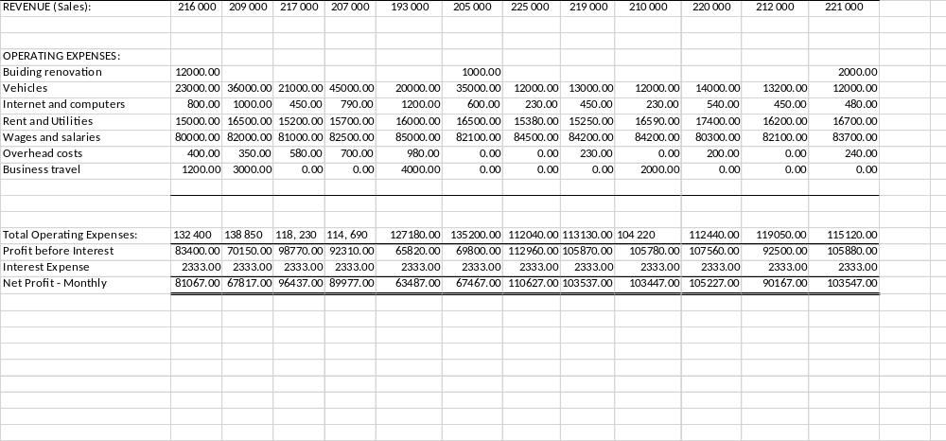

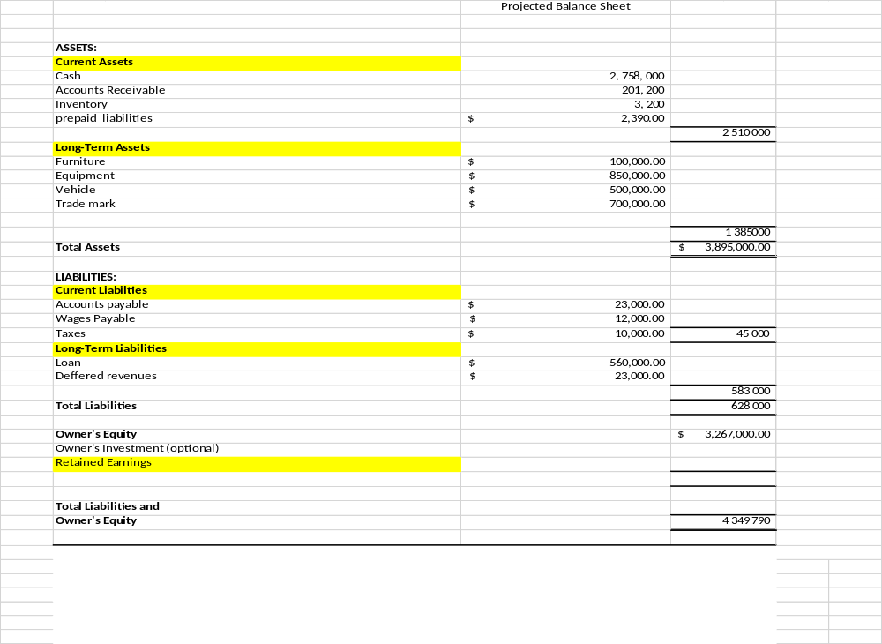

G. Financial Report
G1. Financial Projections: Summarize the financial projections and the assumptions used in estimating the financial statements.
The Company's overall performance was above the expected revenue in the first three months. After several months of navigating through the industry, the management projected to endure a dry spell of losses before gaining foot. In the first month, legal expenses and building renovation ate into the Company's profits. The Company's financial health is expected to be cushioned by installation services, the sale of Tarsier Security Cameras, and the upgrading of Closed-Circuit Television systems to I.P. systems. Registering an owner's equity of C$ 3 267 000 in the first year keeps the Company in a position to prosper further in the future. It will have enough funds to increase employee salaries and expand internationally, as stated in its goals. If other factors remain constant, the Company will go international as planned in the coming seven years.
G2. Financial Position:
The details indicated by the end-year results are valid testimony that the Company shall survive the financial storms associated with industry newcomers and stiff competition from the already established firms. Suppose the Company gradually switches to its value-based pricing system soon. In that case, it is likely to overtake most industry players who fail to innovate by depending on their traditional models. The Company presumably recorded total assets of C$ 3 895 000 and total liabilities of C$ 628 000 at the end of 2022. The difference is an indicator of the healthy financial status of Tarsier Security Company. However, there is a need for the Company to carry out the vigorous promotion of the T.S.C. camera to make it the brand image. It registered lower returns compared to services that the Company considered secondary. The lower prices charged on the product might send a wrong signal to potential customers by perceiving the product as of lower quality. Another key takeaway is the ability of the Company to repay its loan that has a five-interest loan. T.S.C. managed to pay back the minimum C$ 2333.33 every month, indicating that the Company could acquire a larger loan to make other advancements. A close look at the expenses reveals that the Company spends a lot on rent. It will be prudent for the Company to gain financial ability with speed to buy its premises or land to construct its premises. The plan will reduce expenses in the long run. The average profit of C$ 87 000 is a positive gesture writing home. At the start, it reveals the potentiality of doing even better in the future.
G3. Estimated Capital/Investment Needs:
The Company should consider buying a car that can be used for business travels involving shorter distances. Depending on public transport has many shortfalls like lateness. Also, it is prudent that the Company buys its premises to avoid paying rent.

H. References
Allen, J., Grieder, T., Peterson, B., & Roberts, T. (2020). The impact of macroprudential housing finance tools in Canada. Journal of Financial Intermediation, 42, 100761.
Cesaroni, C., & Doob, A. N. (2020). Responding to youth crime in Canada. University of Toronto Press.
Chechurina, M. N., & Grin, A. A. (2020, July). Public-private partnership in the management of ports of the world. In I.O.P. Conference Series: Earth and Environmental Science (Vol. 539, No. 1, p. 012144). I.O.P. Publishing.
Kamali, M., Hewage, K., & Sadiq, R. (2021). Conventional versus modular construction methods: A comparative cradle-to-gate L.C.A. for residential buildings. Energy and Buildings, 204, 109479.
Norris, C., & Armstrong, G. (2020). The maximum surveillance society: The rise of CCTV. Routledge.
Piza, E. L. (2021). The history, policy implications, and knowledge gaps of the CCTV literature: Insights for the development of body-worn video camera research. International Criminal Justice Review, 31(3), 304-324.
Shekelle¹, M., Groves, C. P., Maryanto, I., & Mittermeier, R. A. (2017). Two new tarsier species (Tarsiidae, Primates) and the biogeography of Sulawesi, Indonesia. Primate Conservation, 31, 61-69.
Topno, N. (2019). Globalization Impact on the International Business Development: The Tata Motors Case. МЕНЕДЖМЕНТ И МАРКЕТИНГ: ВЫЗОВЫ ХХI ВЕКА, 218.
Zhang, Z. (2020). Competitive Pricing Strategies for Software and SaaS Products. Information & Management, 57(8), 103367.

